**Lab4 : hosting static site using nginx on aws virtual machine called ec2**

**Theory:**

**Ec2:** EC2 is an online computer you can use to run apps or websites. You can choose how powerful the computer should be and change it anytime.

**Nginx:** Nginx is software that helps websites work faster and handle lots of visitors at the same time. It acts like a middleman, managing and delivering website content to users efficiently. It’s often used to make websites load quickly, balance traffic, and improve security.

**Steps:**

1. Make a ec2 in public subnet.

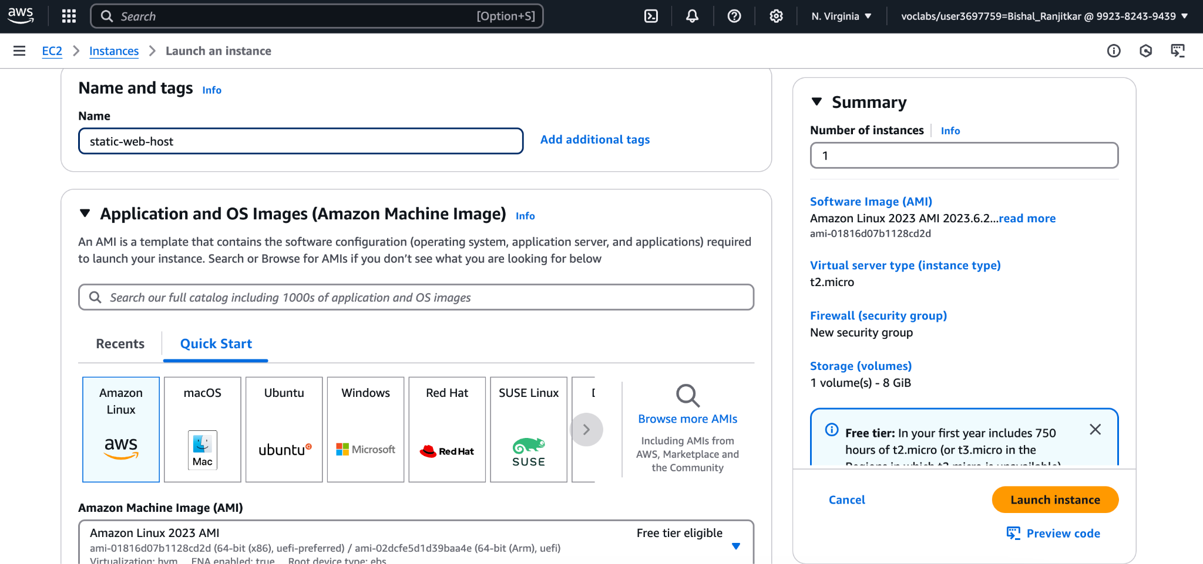

1. Ssh login to the terminal with the help of key. Change into root user And update your computer using “yum update -y”. Install nginx “yum install nginx -y” and start nginx “systemctl start nginx” and “systemctl enable nginx”

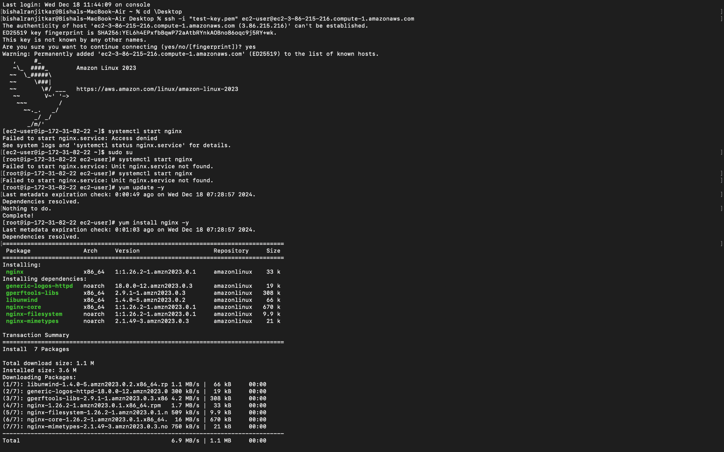

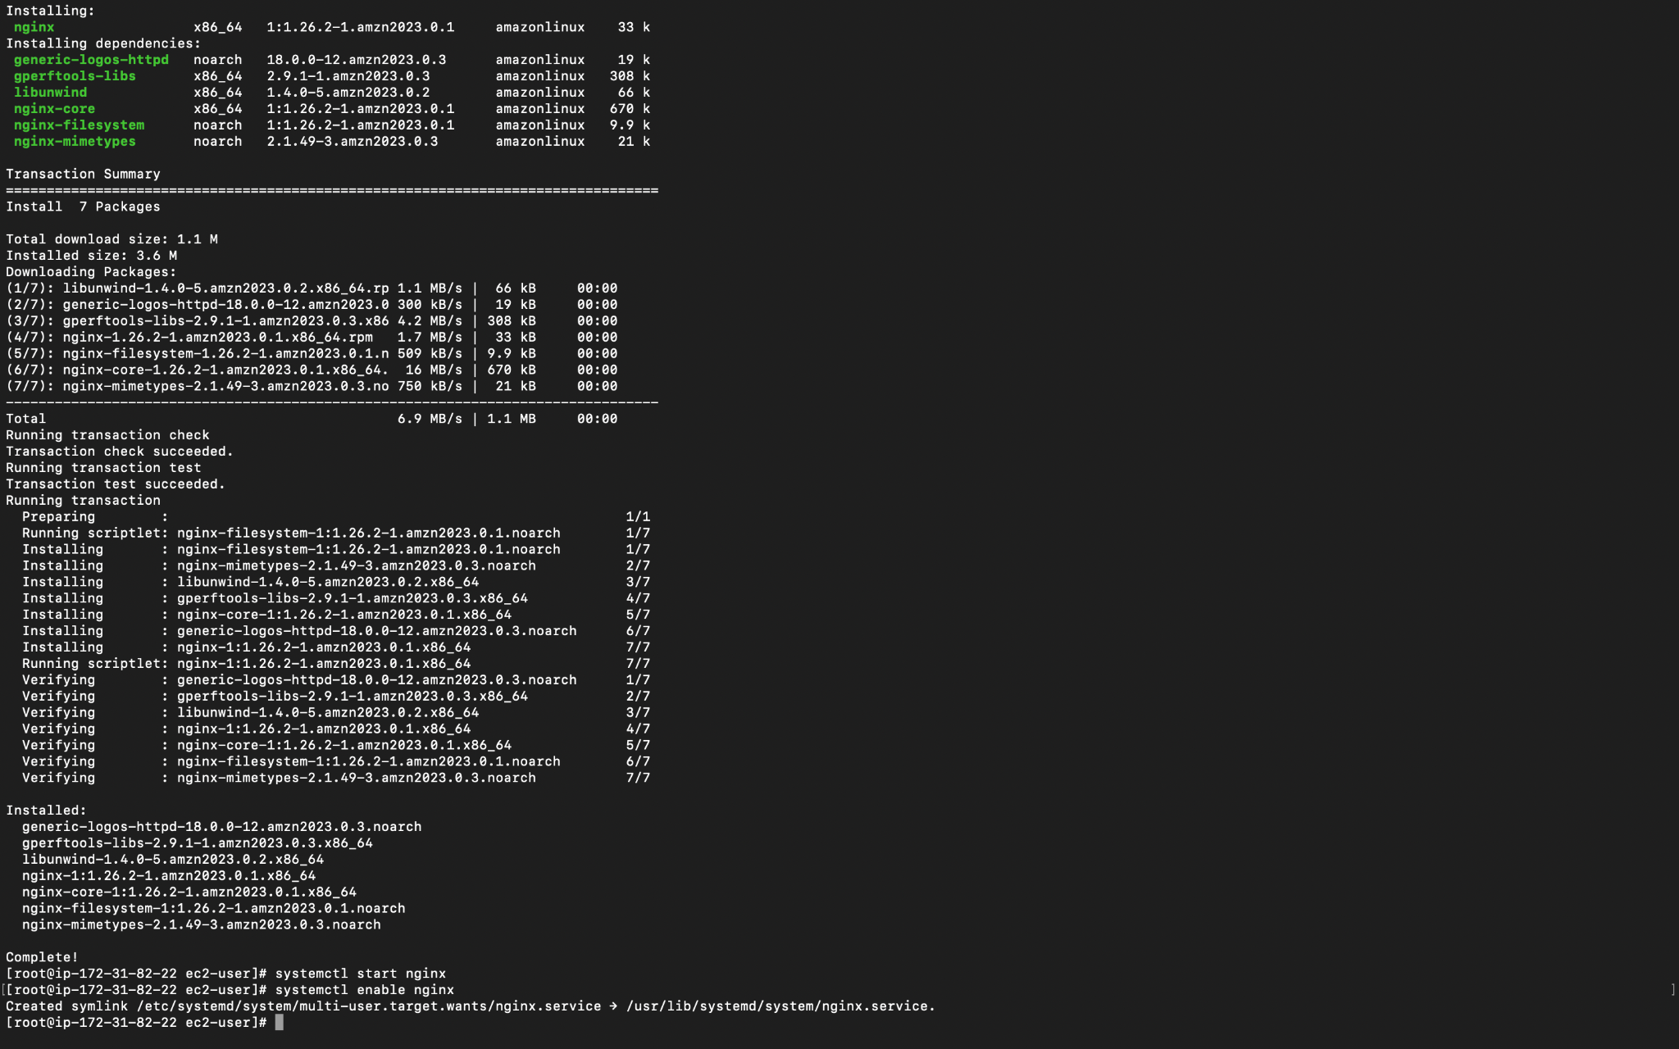

1. Go to usr/share/nginx/htm or var/www/html if you are using ubuntu.and go to index.html with the help of text editor “nano index.html”. Type the html code

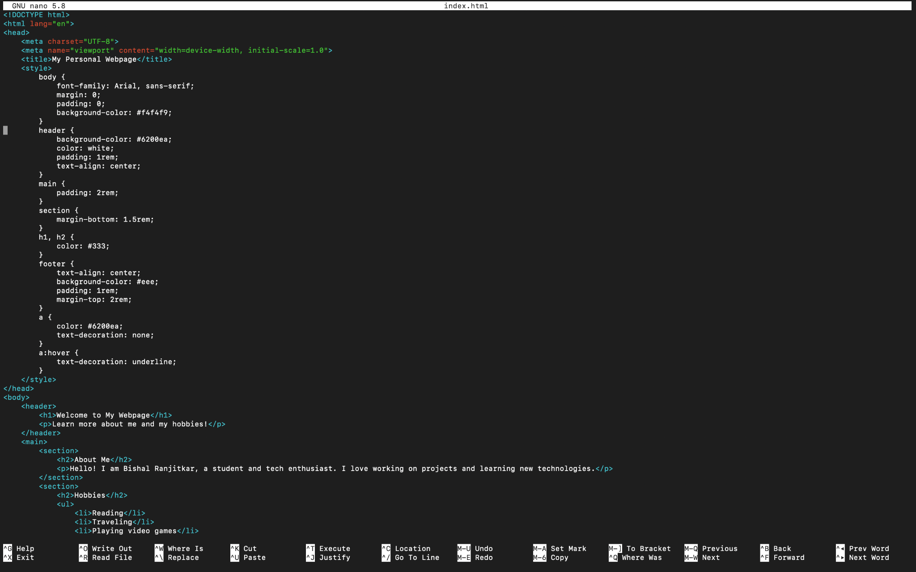

1. Save the code and copy the public ip from the aws console. Search the ip

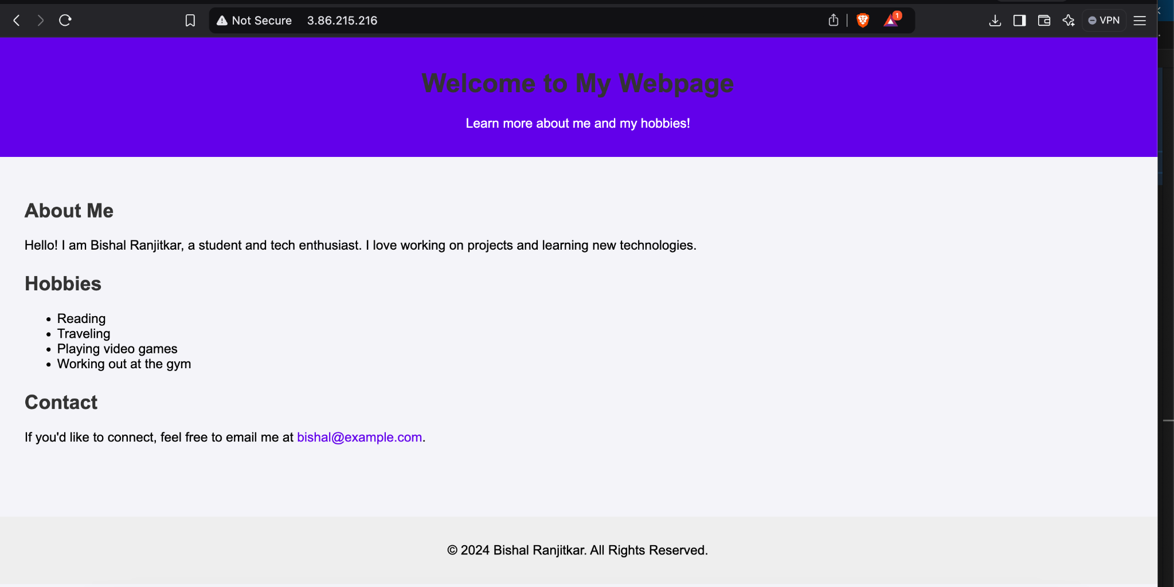

### 

### 

### **Conclusion**

We hosted our static website with the help of Nginx server.

We set up:

1. We created ec2
2. Ssh login using key
3. Changed into root user
4. Install and start nginx
5. Write our code to index.html which is inside usr/share/nginx/html
6. Copy the public ip and search it in search engine